WEEK-09-TWO-DIMENSIONAL AND MULTI -DIMENSIONAL ARRAYS

CODING

Reg no:241801289

Name :Tamilselvan.k

Q1

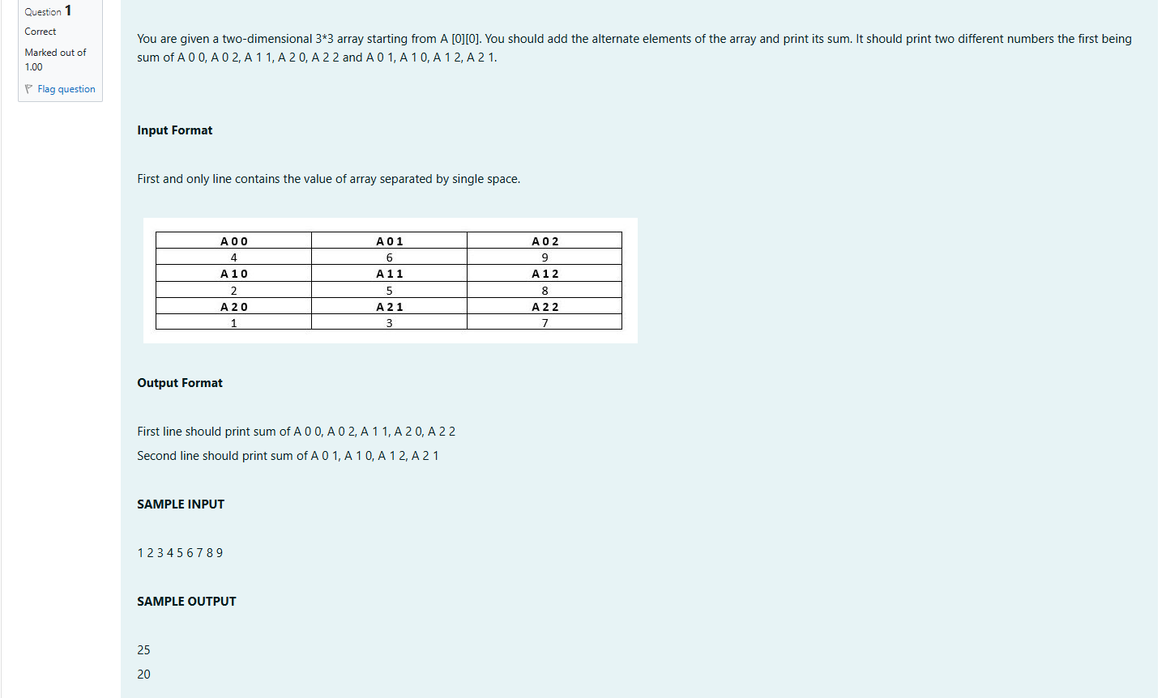

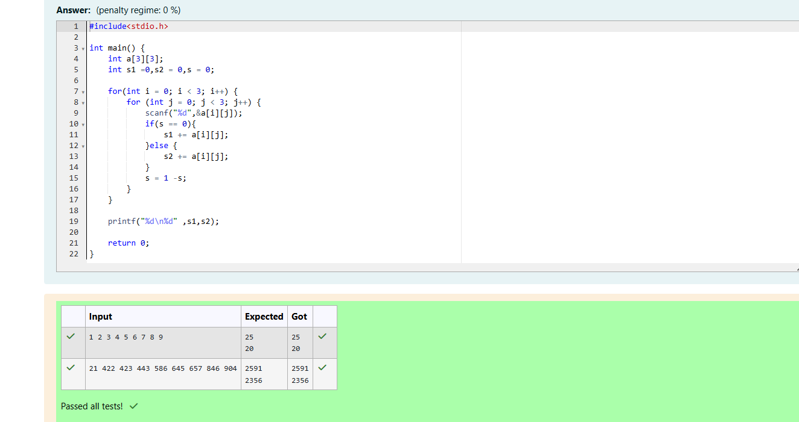

CODING

Reg no:241801289

Name :Tamilselvan.k

Q2

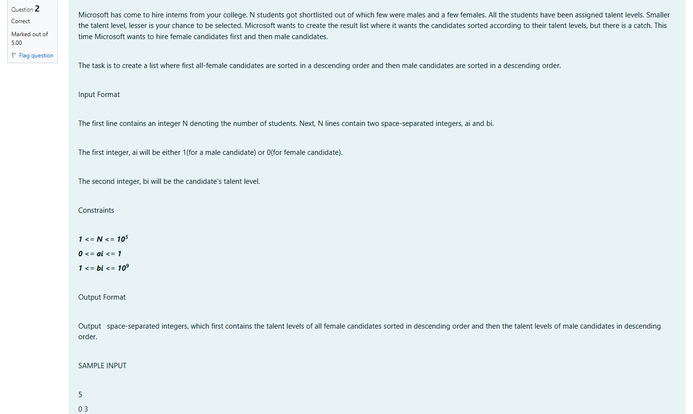

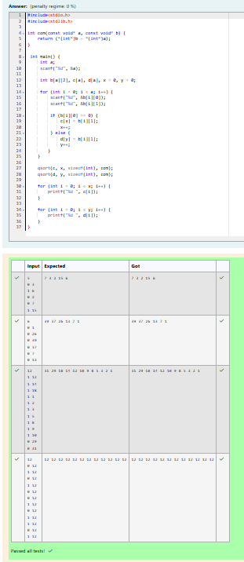

CODING

Reg no:241801289

Name :Tamilselvan.k

Q3

